Name : Al Sifat Siddiki
StudentID : 40735842
Module code:

Library Management System Documentation

Project Overview
The objective of this Library Management System is to provide an efficient way of book, user, and borrowing records management. The system facilitates the addition, modification, deletion, and tracking of books and users.
Functional Requirements
Starting the project with C# in visual Studio code to create in the Windows Forms App(.NET Framework) and name the project Library Management System and connect with file .

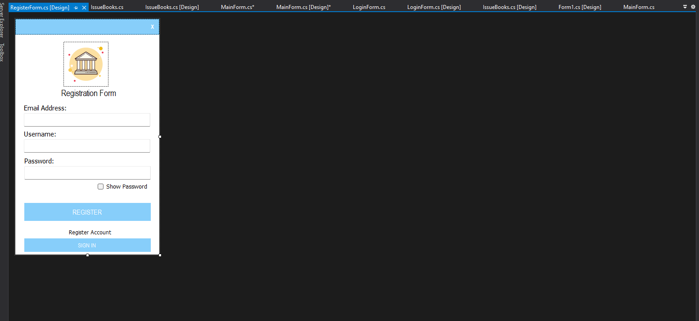
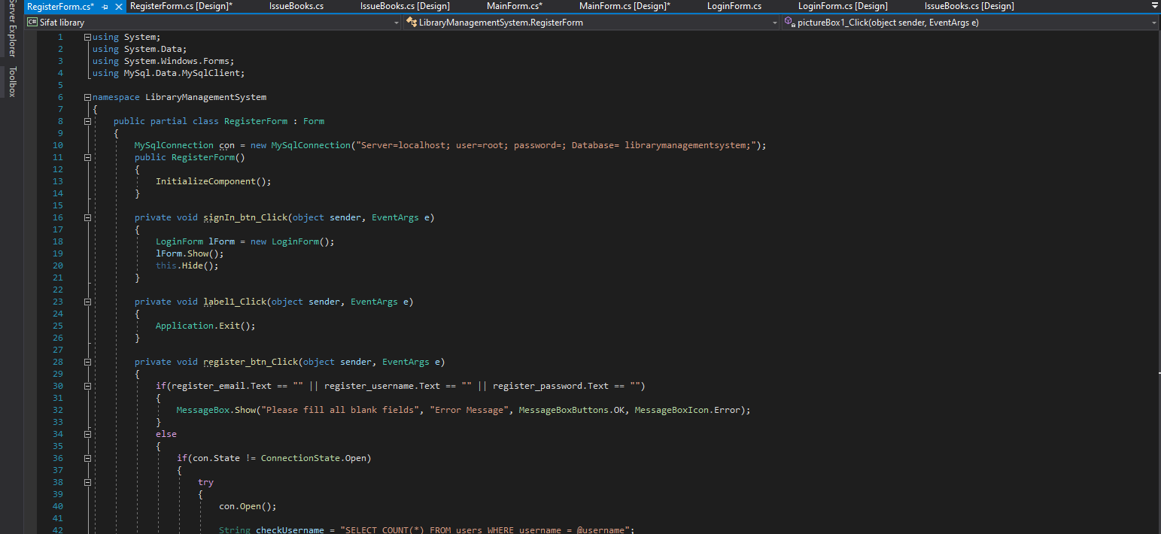

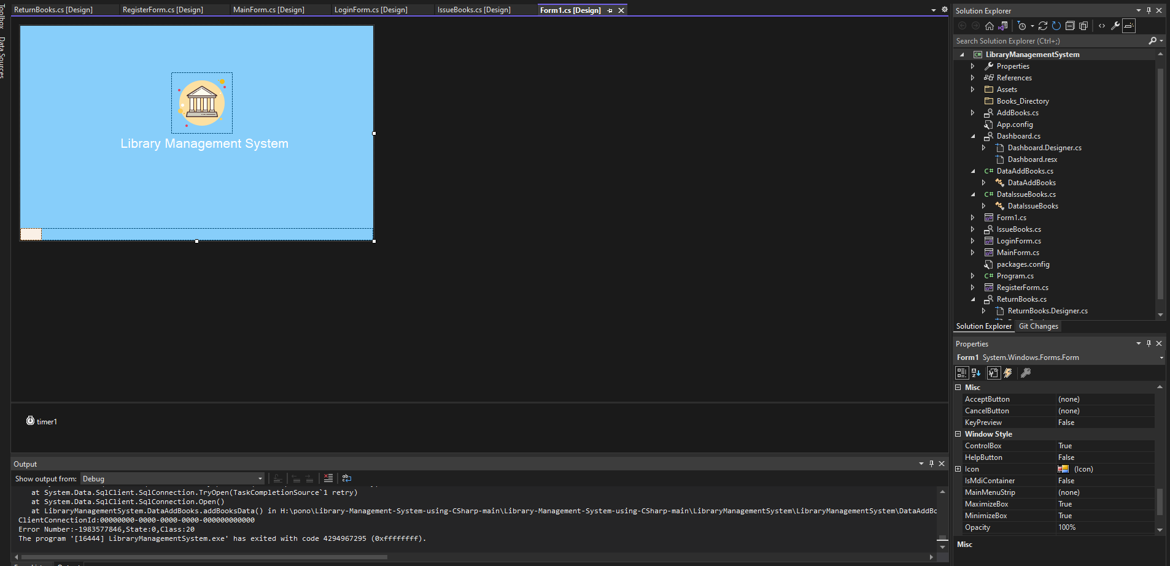
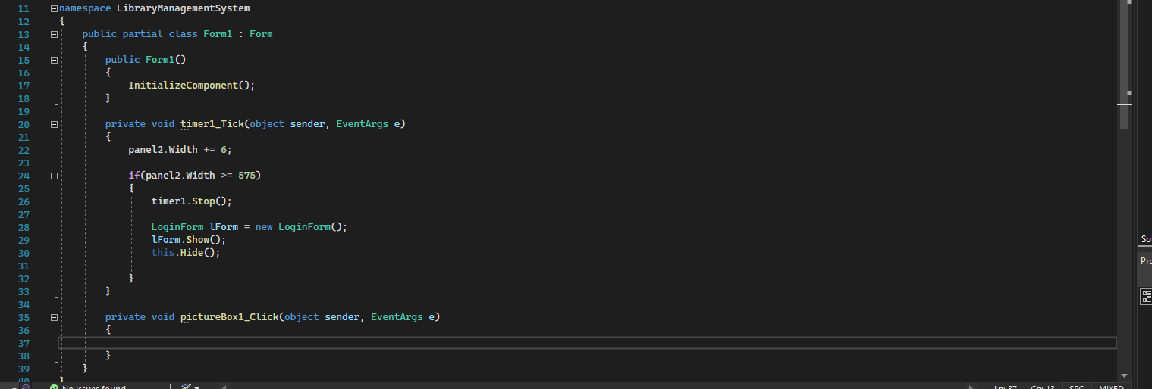After Signup the user using login to go through the book management system where the they can borrow book but the functional system of this management Admin system Add new books to the system to Update existing book details, and Delete out-of-stock books for user so they can easily Search for books based on title, author, or category.
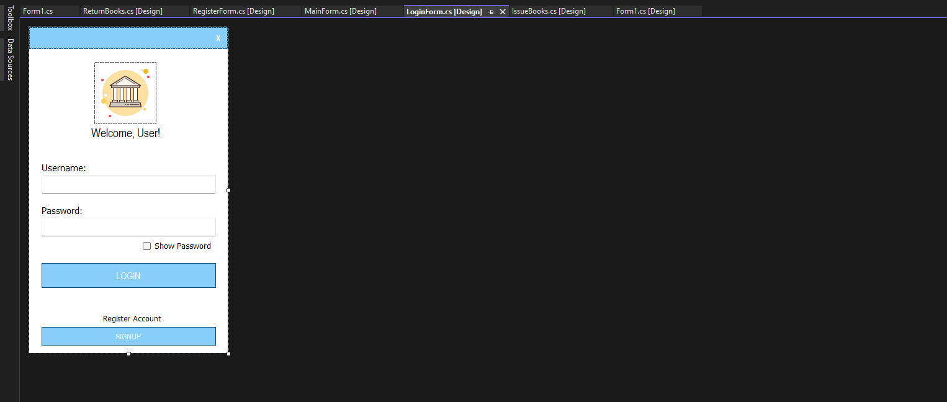
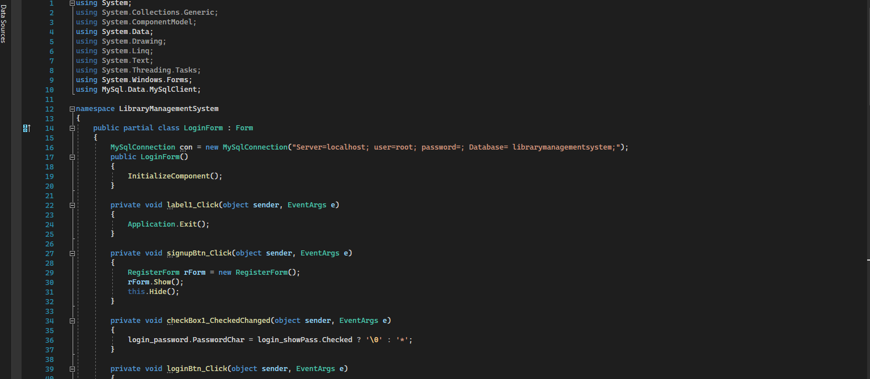

For the User Management add new users. Delete users who are no longer in the system. Update user information in the SQL and connect to visual code. Also, the Borrowing and Returning Books facilitate borrowing books by users. Deal with due dates and return status.

Implement a fine system for overdue books & System Design
The application is built using C# and a structured backend for handling data and connecting to SQL to run the command efficiently. Book Management Flowchart Illustrates adding, updating, and deleting books. User Management Flowchart Explains adding, deleting, and updating users. Borrowing Process Algorithm to User logs in. Searches for available books. Requests to borrow a book. Where the System checks availability. If available, the book is assigned to the user. Also, the Due date is generates returns the book within the due date.
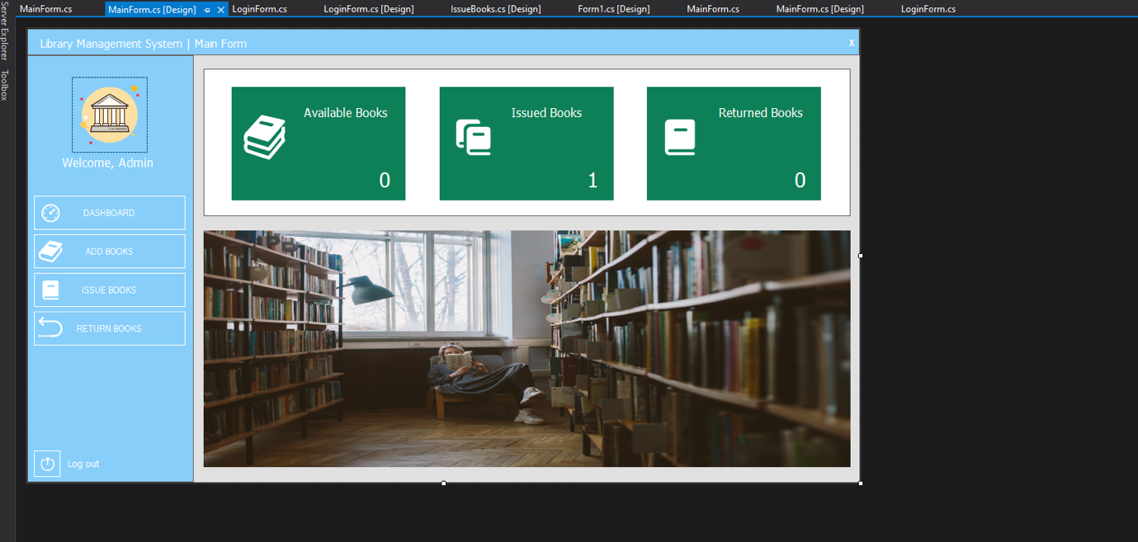
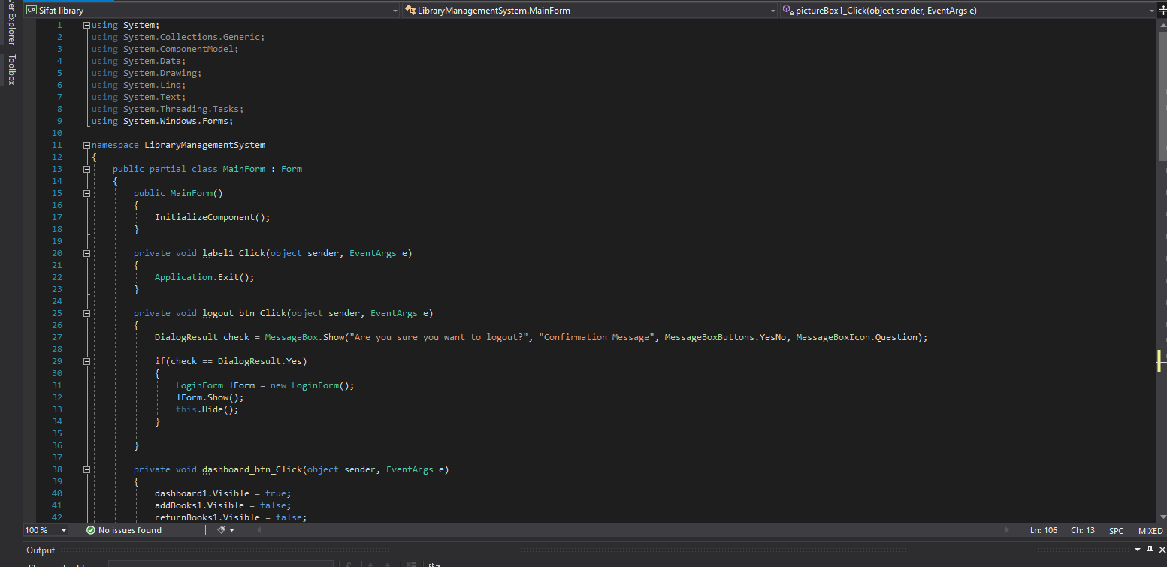
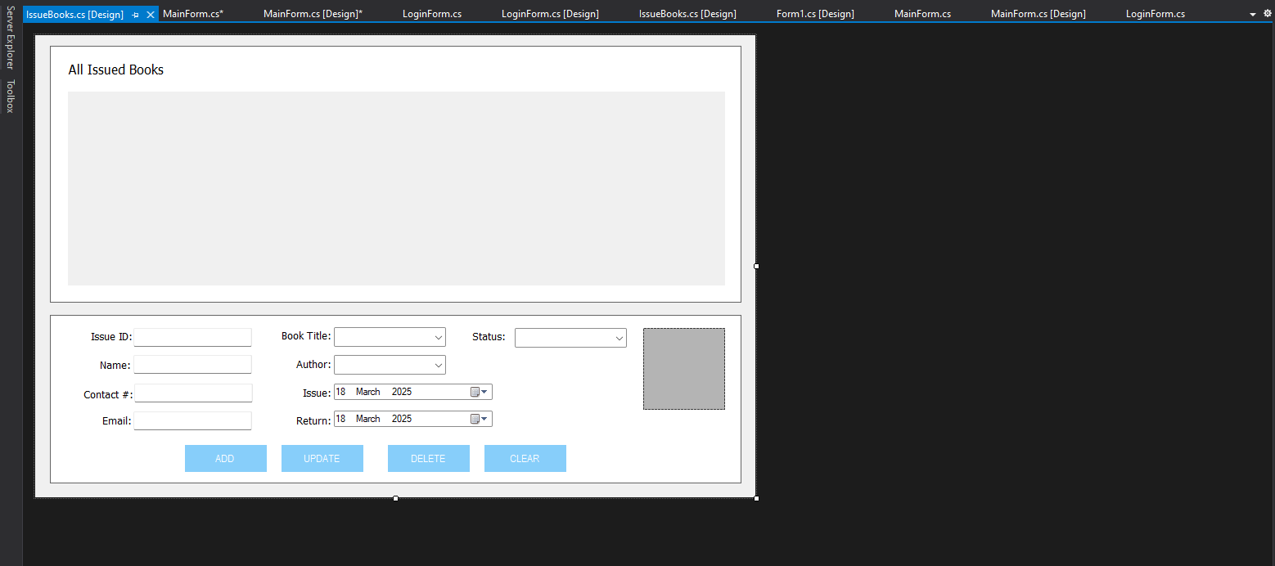
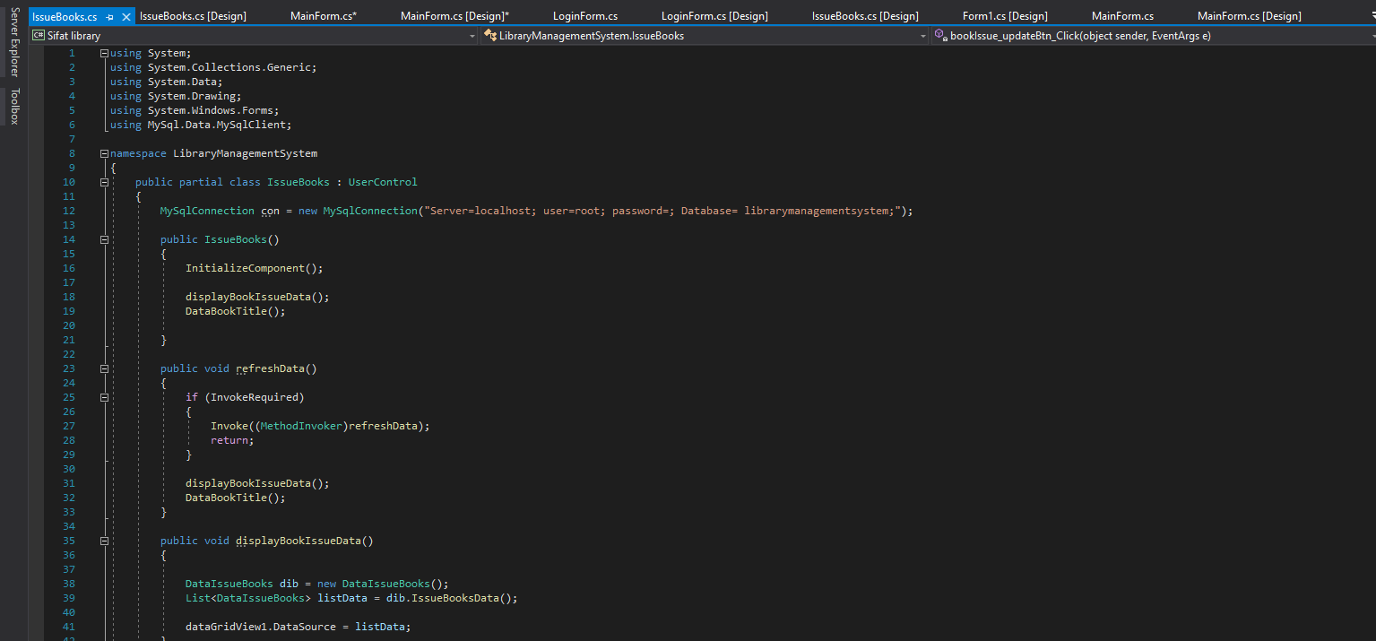
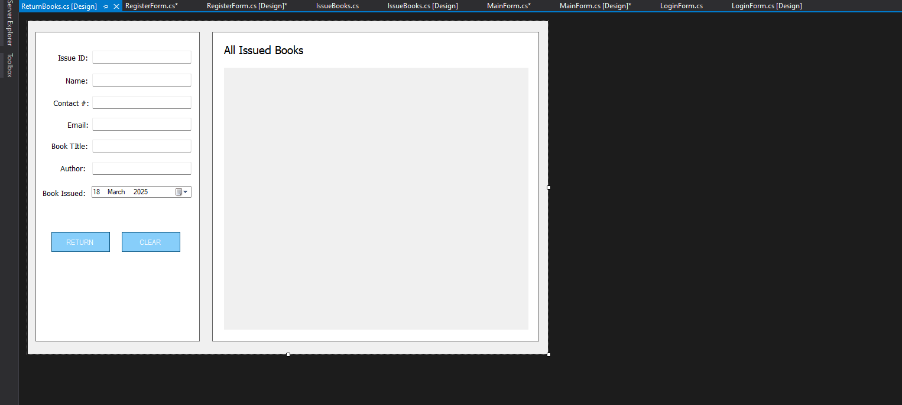
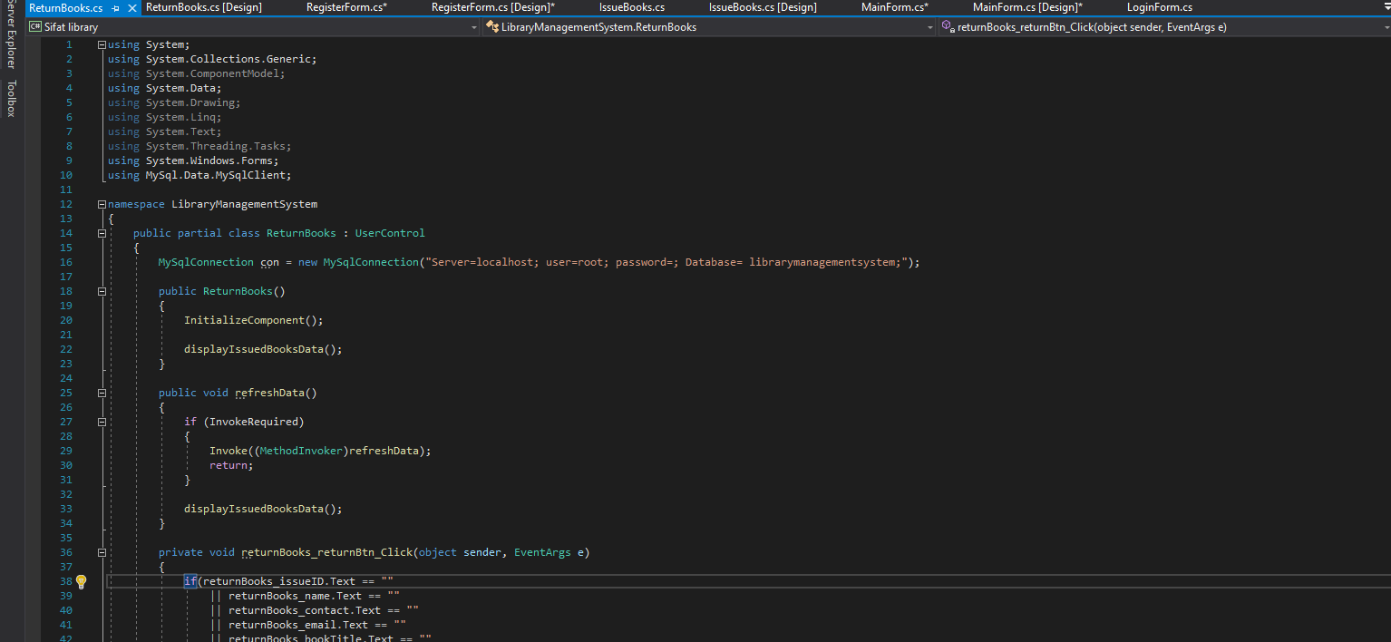

Testing
For testing the case ID 001 and mail Id ace@gmail.com, number 777333 name Sifat and added successfully and assigned to user to use and return a book late will be Screenshots of successful and failed test cases can be included in the final report.

Challenges and Solutions
The challenges that creates the error is when try to connect with SQL and create books, issues table on SQL to run the code and make it similar command to implement the result in every from there; where errors to following command to run the code with the MySQL Connection and con to MySQL Command find tout the errors properly to fix the errors and make a fresh code to implement and running and testing the code.

Conclusion
Developed a full-fledged C# with SQL database Library Management System with book and user management. Executed secure login and successfully tested major functionalities. Include a graphical user interface (GUI) to provide a better user experience. Add online booking capabilities to the system. Use email reminders for due dates.

